This document gives an overview of the work.

**ESP_A Folder**

There are two folders in the sample folder: the **original** and the **generated**, containing the reconstructed wave. The NSynth dataset was used.

***The preprocess.py***

In this file, the *waveform* is encoded to an stft-based representation; it employs the reassigned spectrogram and wavelet scattering transform; however, those lines of code has been commented

***The visualize.py shows***

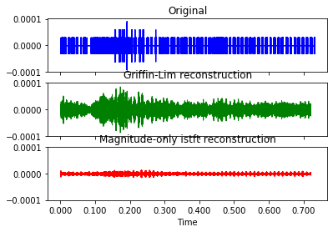

***The Soundgenerator.py***

After training in train.py, the STFT inverse is applied. It also applied the Griffin-Lim; however, that line of code has commented in the soundgenerator.py

***The train.py***

For training, the epoch is set 150, batch size 64, and learning rate 0.0005

***The generate.py***

This script generates and stores the wave in the **generated** folder

***The visualize.py***

This script visualizes the original, Griffin, and **istft**

***The autoencoder.py***

A variational autoencoder is employed for encoding and decoding